Levi George

10/24/2020

Professor Venkata Inukollu

CS 36000: Software Engineering

Homework 2

* 1. There is a Hospital Database component, payroll system, there is also a system for tracking which rooms are occupied, a system that is used for paying bills, and some system that is used for booking appointments. It should be noted that the appointment reservation system and database may include some relationship, however, I elected to offload that communication to the Management System.
  2. 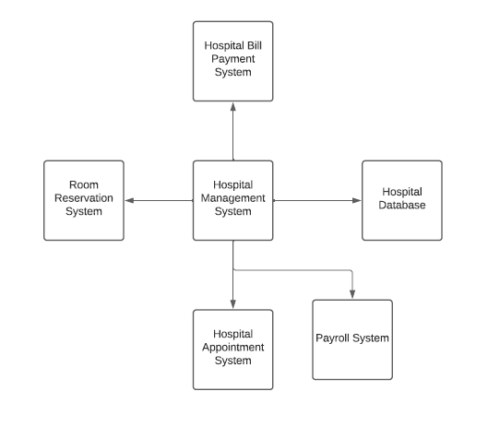
  3. There are several classes, we know that at the minimum there is a Patient, Appointments, Staff, and Patient History. The Patient History will consist of all the testing information the patient undergoes. The Patient would have a name, age, SSN, ID, room (if they are staying), paymentInfo if they want automated payments, and a patientFile which would be an object that stores all of the patients information in a linked list or binary tree.
  4. The methods of the patient would involve some of the basic setters and getters, but also a confirmation function that is used to send the patient or staff the patient ID. However, in order to get the patient history or their file, you would need an appropriate ID, this way it enforces HIPPA constraints.
  5. Diagram

     Description automatically generated
  6. The System will include numerous times where it must wait for the user to enter information or make some decision. Additionally, it will process and move information between the forms that the staff use into the database for later use. There will be some instances of the system communicating with the database. If the patient is paying a bill then they will open the system see the options, they can select any bill they wish to pay, the system will get details about the bills, from there they can see the details and pay some amount, then remove the amount entered, once they confirm the bill it will display confirmation if the payment went through.
  7. The image has been included, however, in many situations the Patient in a hospital has little to do with setting up their account, so I elected to write a state model of the Patient making a payment for some bill they have with the hospital and setting an appointment.

* 1. Sequence Diagram has been included
  2. Diagram

     Description automatically generated